CHAPTER 1
INTRODUCTION
1.1 Introduction to the Seminar Title
Few technological ideas have captured collective imagination as rapidly as the Metaverse. Although the word itself was introduced to popular culture through Neal Stephenson's 1992 novel in which a protagonist navigates a sprawling digital realm using a virtual avatar the underlying aspiration — a digital space indistinguishable in richness from physical reality — had been a recurring theme in both fiction and technology research for decades before Stephenson gave it a name [1].
What distinguishes today's Metaverse conversation from earlier visions of cyberspace is the technological maturity now available to pursue it. Graphics processing units capable of rendering photorealistic environments in real time wireless networks that can transmit data at speeds previously restricted to wired connections compact wearable displays that sit on the human face and project stereoscopic three-dimensional imagery and distributed computational systems that allow millions of users to share a single persistent environment — none of these were practically available in 1992 [2].
The commercial turning point arrived in late 2021 when one of the world's largest social media companies restructured its entire corporate identity around the Metaverse vision renaming itself to signal that its future lay not in two-dimensional social feeds but in immersive shared worlds [3]. This announcement triggered a wave of corporate investment and public curiosity that brought Metaverse into mainstream discourse. Analysts projected the market to expand from tens of billions of dollars in the early 2020s to well over a trillion dollars before the decade concludes at growth rates that rival the early commercial internet [4].
This seminar examines what Metaverse is how it works architecturally where it is being applied and what challenges its responsible development must overcome.
1.2 Description of the Seminar Concept
Understanding the Metaverse requires moving beyond any single platform or product definition. No one company owns Metaverse just as no single company owns the internet. Rather the Metaverse is best understood as a set of interconnected principles technologies and standards that — when realised together — produce a shared persistent immersive digital environment.
Three properties are considered essential for any environment to qualify as a true Metaverse. The first is persistence: the digital world must continue to exist and evolve independently regardless of how many users are logged in at any given moment. Time passes events unfold and economies function even when no human is present unlike a video game that pauses when the player closes the application [5]. The second property is real-time shared presence: users from any location on Earth should be able to occupy the same virtual space simultaneously with their actions visible to and felt by others with negligible delay. The third property is interoperability: a user's identity digital possessions and earned reputation should travel seamlessly across different virtual environments just as a mobile phone number remains usable regardless of which network's coverage area the user enters [6].
Achieving these three properties requires contributions from multiple technology domains working in concert. The architectural model most widely cited to organise these contributions is the seven-layer framework which describes the Metaverse as a stack beginning with physical infrastructure at the base and rising through hardware interfaces decentralised trust systems spatial computing environments creator tooling content discovery mechanisms and finally the experiential applications that end users interact with [7].
Among the enabling technologies extended reality hardware provides the sensory interface through which users enter the Metaverse. Virtual reality headsets create fully enclosed digital environments by displaying stereo imagery directly in front of each eye; augmented reality devices overlay digital content onto the user's physical view of the world; and mixed reality systems allow virtual objects to interact with real-world surfaces and lighting conditions [8]. Distributed ledger technology — most commonly blockchain — provides a mechanism for establishing provable ownership of digital assets without relying on any central authority making concepts such as digital land deeds and unique collectible items technically feasible [9]. Artificial intelligence contributes at every layer from generating three-dimensional environments procedurally to animating virtual characters with believable behaviour and enabling users to interact with the system using natural spoken or written language [10]. High-capacity wireless networks are the transport medium through which all this data flows; the sub-millisecond response times and multi-gigabit throughput of fifth-generation mobile networks are widely regarded as a prerequisite for comfortable immersive experiences at scale [11].
1.3 Applications of the Concept
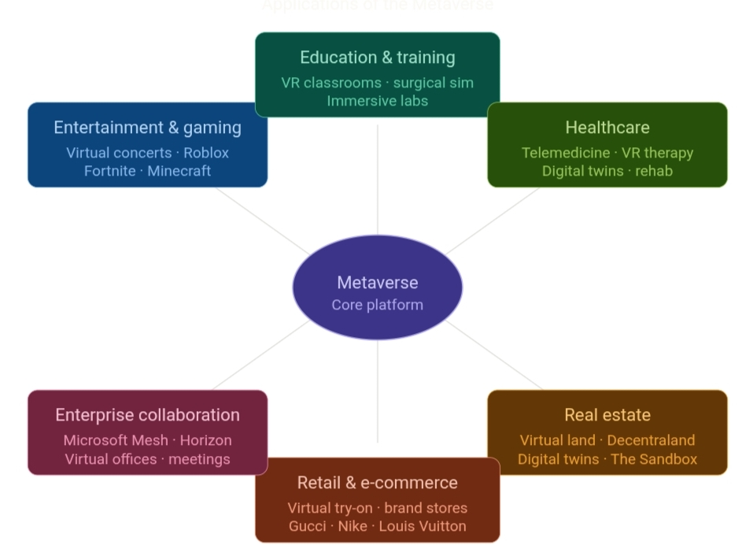
The practical impact of Metaverse technologies is already visible across a wide range of sectors. The following subsections describe the most significant application areas.

Figure 1.1: Applications of the Metaverse

1.3.1 Entertainment and Gaming
The games industry has functioned as an unplanned incubator for proto-Metaverse experiences. Several major gaming platforms already host tens of millions of concurrent users within persistent shared environments offering not just gameplay but concerts film screenings community gatherings and in-world commerce [12]. When a major battle-royale game hosted a live music event with a well-known rapper that drew attendance figures comparable to major physical festivals it demonstrated that virtual shared spaces could deliver culturally significant collective experiences at scales impossible in the physical world [13].
1.3.2 Education and Training
Immersive environments offer an alternative to passive instruction by placing learners inside the subject matter rather than outside looking in. A student learning anatomy can inhabit a scaled-up model of the human heart; one studying ancient history can walk through a reconstructed marketplace; one training as a surgeon can rehearse a delicate procedure dozens of times without any patient risk [14]. Several large corporations have already replaced portions of their conventional training curricula with virtual reality programmes and have reported measurable gains in both the speed of skill acquisition and the durability of what was learned [15].
1.3.3 Healthcare
Medical applications span diagnosis treatment rehabilitation and training. Clinicians in one location can conduct detailed consultations with patients elsewhere using avatars that preserve spatial cues and body language. Patients recovering from physical injury can follow rehabilitation protocols in virtual environments that motivate engagement and accurately record progress. Surgeons can rehearse operations on precise digital replicas of a specific patient's anatomy before making the first incision [16]. In mental health controlled virtual environments are being used to conduct graduated exposure therapy for anxiety-related conditions with outcomes in several clinical studies comparable to those achieved through conventional in-person sessions [17].
1.3.4 Real Estate and Architecture
A category of digital asset that behave like land — occupying a defined coordinate within a virtual world buyable sellable and developable — has emerged on several blockchain-based platforms. By the early 2020s total transaction volumes in this category had surpassed half a billion US dollars with major commercial brands securing virtual premises to host branded experiences and product launches [18]. In the physical construction industry architects and urban planners increasingly use precise three-dimensional digital replicas of proposed buildings to evaluate design options simulate environmental conditions and coordinate construction workflows before any physical work begins.

1.3.5 Retail and E-Commerce
The limitations of flat product photography are well understood by online retailers. Metaverse technologies offer an alternative in which customers can examine products from all angles place virtual furniture in a three-dimensional model of their actual room or try on digital representations of clothing using a personalised avatar that matches their measurements [19]. Luxury fashion houses and sportswear brands have been early adopters of this approach launching exclusive virtual product lines that exist only as digital assets and hosting immersive brand events within virtual worlds to reach audiences who may never visit a physical store.
1.3.6 Enterprise Collaboration
Distributed workforces became the norm for many organisations during the pandemic period and conventional video conferencing — despite its utility — has well-documented limitations in replicating the spatial and social dynamics of physical co-presence. Metaverse-based collaboration tools allow remote colleagues to occupy shared three-dimensional workspaces interact with three-dimensional data visualisations and documents conduct spatial walkthroughs of product prototypes and engage in informal lateral exchanges that are difficult to replicate in a grid of small video windows [20].

1.4 Architecture Diagram
The Metaverse is architecturally organised as a vertical stack of interdependent layers. Each layer depends on the one beneath it and provides services to the one above it. The seven-layer model described here follows the framework adapted from Jon Radoff's analysis of the Metaverse value chain.

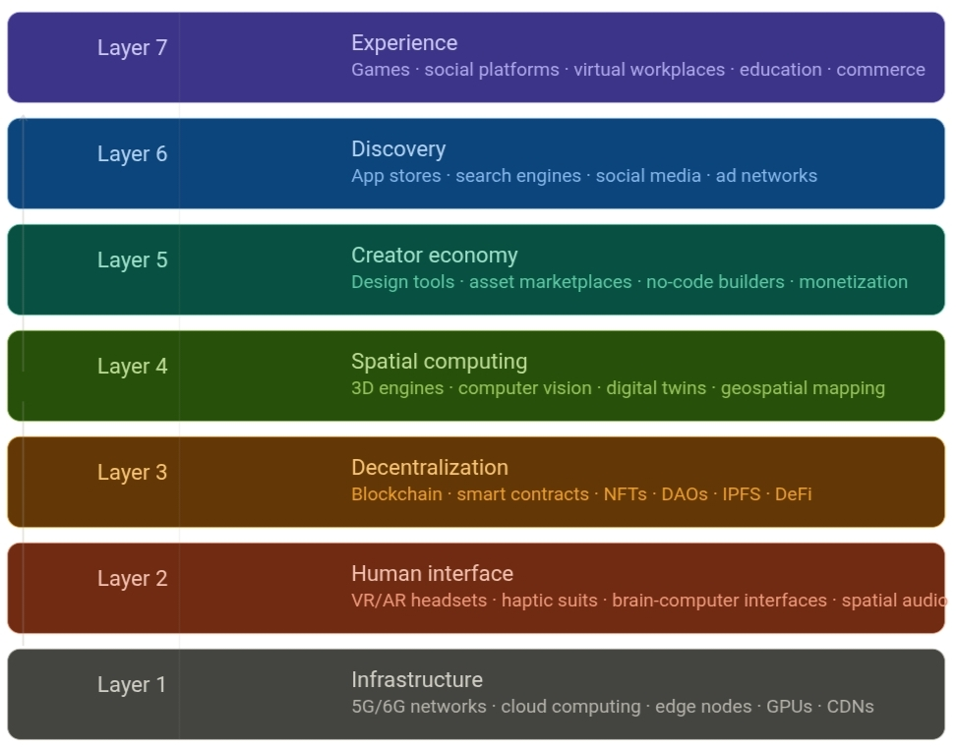

Figure 1.1: Metaverse Architecture Diagram — Seven-Layer Model

Layer 1 — Infrastructure forms the physical and computational foundation on which all other layers rest. It comprises the global telecommunications networks that carry data between users and servers the cloud computing facilities that host virtual world state the specialised processor hardware that renders three-dimensional graphics and runs artificial intelligence workloads and the content delivery infrastructure that ensures low-latency access regardless of geographic location.
Layer 2 — Human Interface encompasses all the devices and software through which a human being perceives and acts within the Metaverse. This layer currently includes stereoscopic head-mounted displays optical see-through glasses for augmented reality gloves and suits equipped with tactile feedback actuators systems that track the precise position and orientation of the user's head and hands and spatial audio hardware that places sound accurately in three-dimensional space.
Layer 3 — Decentralisation provides the trust infrastructure that allows the Metaverse to function without a single controlling authority. Blockchain networks record ownership of digital assets in a distributed ledger that no single party can unilaterally alter. Smart contracts automate transactions and enforce agreements according to pre-agreed rules. Decentralised storage systems retain asset files in a distributed fashion ensuring availability even if individual servers go offline.
Layer 4 — Spatial Computing is where the digital world is constructed and maintained. Three-dimensional game engines simulate physics render environments and manage the interactions of objects and avatars in real time. Digital twin systems maintain accurate virtual replicas of physical objects or environments updated continuously from sensor data. Geospatial mapping technologies anchor virtual content to real-world coordinates.
Layer 5 — Creator Economy consists of tools platforms and economic mechanisms that enable individuals and organisations to design and monetise Metaverse content. This includes professional three-dimensional modelling software accessible no-code world-building tools digital asset marketplaces where creators list their work for purchase and the token-based economic systems that distribute revenue to contributors.
Layer 6 — Discovery manages how users learn about and navigate Metaverse experiences. Search and recommendation systems surface relevant content; social feeds propagate information about events and places; application directories curate available experiences; and advertising networks connect brands with audiences inside virtual environments.
Layer 7 — Experience is the layer that end users inhabit. It encompasses every interactive application built on the layers beneath it — social worlds competitive games virtual workplaces educational simulations entertainment venues digital commerce spaces and the many hybrid forms that do not fit neatly into any single category.

CHAPTER 2
LITERATURE REVIEW
2.1 Literature Survey
A systematic survey of peer-reviewed publications industry white papers and authoritative technical reports was undertaken to map the current state of knowledge about the Metaverse. The following paragraphs summarise the most significant contributions identified.
Mystakidis (2022) offered a widely adopted academic framing of the Metaverse in the context of educational technology characterising it as a successor to current internet paradigms that fuses ongoing physical experience with continuous digital presence [1]. His analysis was notable for drawing a clear distinction between immersive shared worlds and the earlier Web 1.0 and Web 2.0 generations of the internet arguing that the shift to the Metaverse is qualitatively different rather than merely quantitative. This taxonomy has since been adopted or adapted by numerous subsequent researchers as a starting point for their own definitions.
Lee and colleagues (2021) produced one of the earliest comprehensive academic surveys of the entire Metaverse domain reviewing a large body of prior research and proposing a classification framework they called ALMA which organises Metaverse applications into four categories based on their relationship to reality and the degree of user logging they involve [2]. Their analysis concluded that the greatest barrier to a fully realised Metaverse is not any single technology but rather the challenge of keeping physical and digital states synchronised continuously and at scale.
Ning and co-authors (2021) approached the subject from a systems engineering perspective analysing the full stack of enabling technologies — rendering engines extended reality hardware distributed ledger systems digital twin infrastructure and artificial intelligence — and proposing a three-tier reference architecture that separates concerns at different levels of abstraction [3]. Their paper identified the absence of agreed interoperability standards across platforms as the dominant obstacle to a genuinely unified Metaverse experience.
Dionisio Burns and Gilbert (2013) conducted foundational work on the theoretical properties that any environment must exhibit to warrant being called a Metaverse arriving at four criteria: photorealistic visual fidelity access from any device or location the ability to transfer assets and identity between worlds and the capacity to support very large numbers of simultaneous users without degradation [4]. Although published before the current wave of commercial interest in the Metaverse this framework has proven durable and is still cited extensively in contemporary work.
Park and Kim (2022) examined the Metaverse specifically through the lens of educational technology constructing a detailed taxonomy of components use cases and unresolved challenges [5]. Drawing on a wide range of empirical studies they found consistent evidence that learners in immersive virtual environments outperformed those in conventional settings on measures of engagement information retention and collaborative problem-solving though they cautioned that the quality of pedagogical design mattered as much as the technology itself.
Huynh-The and colleagues (2023) surveyed the intersection of artificial intelligence and the Metaverse in depth cataloguing the roles that machine learning systems play across every layer of the Metaverse stack [6]. Their analysis highlighted generative models — systems capable of producing novel three-dimensional objects environments and animated characters from text descriptions or other inputs — as the most transformative development on the horizon potentially reducing the cost of Metaverse content creation by orders of magnitude.
Wang and co-authors (2022) focused specifically on the security and privacy dimensions of Metaverse economies built on blockchain foundations [7]. They examined the technical standards underlying non-fungible token systems the governance structures of decentralised autonomous organisations and the novel economic models that have emerged in blockchain-based gaming. Their analysis identified vulnerabilities in smart contract code and the limited transaction throughput of first-generation blockchain networks as the two most pressing technical concerns for this domain.
Falchuk Loeb and Nack (2018) raised alarm about data privacy in immersive virtual environments at a time when commercial interest in the Metaverse was still modest [8]. They identified that devices capable of tracking a user's gaze body movements emotional responses and social interactions within a virtual world collect a category of personal data far more intimate than anything gathered by conventional social media and argued that existing privacy regulatory frameworks were inadequate to address this.
Duan and colleagues (2021) moved beyond theoretical analysis to build and evaluate an actual Metaverse prototype within a university campus setting [9]. Their system supported virtual versions of common campus activities including guided tours laboratory sessions and academic conferences. The evaluation demonstrated that users were able to perform these activities in the virtual environment with a satisfactory degree of realism and social presence providing empirical grounding for claims about the educational utility of Metaverse platforms.
Tlili and co-authors (2022) conducted a meta-analysis of published research on Metaverse use in education examining dozens of empirical studies to identify consistent findings and contradictions [10]. While the overall picture was positive — immersive technologies generally improved learning outcomes — the analysis also uncovered significant inequity concerns. Students without access to adequate hardware or high-speed connectivity were systematically excluded from these benefits raising questions about whether Metaverse-based education might widen rather than narrow existing educational disparities.
Ball (2022) offered a practitioner's perspective grounded in years of reporting on the games and technology industries [11]. His central argument was that the Metaverse should be understood not as a product but as a new computing platform analogous to the mobile smartphone ecosystem — one that will host its own economy its own creative industry and its own social norms — and that the transition to this platform will take considerably longer than optimistic corporate timelines suggest.
Radianti and colleagues (2020) undertook a systematic review of immersive virtual reality specifically in higher education contexts analysing the methodology outcomes and limitations of a substantial body of empirical studies [12]. They found the strongest evidence for VR's effectiveness in training procedural skills where physical practice is dangerous expensive or otherwise impractical and identified the high cost of producing educational VR content and the limited availability of suitable hardware as the principal barriers to broader adoption.
Cheng and co-authors (2022) examined the relationship between digital twin systems and the emerging Metaverse arguing that accurate continuously updated virtual replicas of physical systems provide the most technically sound foundation for Metaverse environments that need to reflect real-world conditions [13]. Their analysis discussed how the convergence of sensor networks cloud computing and high-fidelity simulation is making this vision increasingly practical at industrial scales.
Zhou and colleagues (2021) provided one of the earliest focused treatments of Metaverse applications in clinical medicine developing a conceptual framework that maps specific healthcare use cases to the technical capabilities required to support them [14]. Their analysis gave particular emphasis to the importance of tactile feedback — the ability to simulate the physical sensation of touching or manipulating objects — for surgical training and rehabilitation applications where the sense of touch carries important information.
2.2 Summary of the Literature Survey
Drawing together the fourteen contributions surveyed above several recurring themes emerge that define the scholarly consensus on the Metaverse.
The first theme is technological convergence. No single paper frames Metaverse as a product of any one technology. Every treatment of the subject emphasises that the Metaverse arises from the combination of multiple independently advancing fields — immersive hardware distributed systems artificial intelligence and high-capacity networking — whose simultaneous maturation has made the concept practically pursuable for the first time.
The second theme is the centrality of the interoperability challenge. Whether researchers approach the Metaverse from a computer science educational commercial or policy perspective the inability of current virtual environments to exchange users assets and identity information across platform boundaries is identified as the defining technical obstacle. Resolution of this challenge will require industry-wide agreement on open standards analogous to those that created the interoperable web [15].
The third theme is demonstrated application value alongside access inequality. Empirical studies across education healthcare and enterprise domains consistently report that immersive virtual technologies produce measurable improvements in the outcomes they are applied to. However the same studies consistently note that these benefits are not equally accessible because the hardware and connectivity requirements exclude users in lower-resource settings.
The fourth theme is economic innovation accompanied by speculative risk. The blockchain-based ownership systems that distinguish the Metaverse from previous virtual worlds have enabled genuinely novel economic arrangements but they have also attracted speculative behaviour attracted regulatory scrutiny and — in the case of proof-of-work blockchain networks — consumed significant energy.
The fifth theme is an emerging awareness of psychological and privacy risks. The most recent literature increasingly attends to the intimacy of the data that immersive virtual environments collect and the potential for prolonged immersion to affect mental health and social behaviour. These concerns have not yet been resolved by either technical or policy means and the literature calls for dedicated longitudinal research.

CHAPTER 3
TECHNICAL SIGNIFICANCE
3.1 Technological Developments
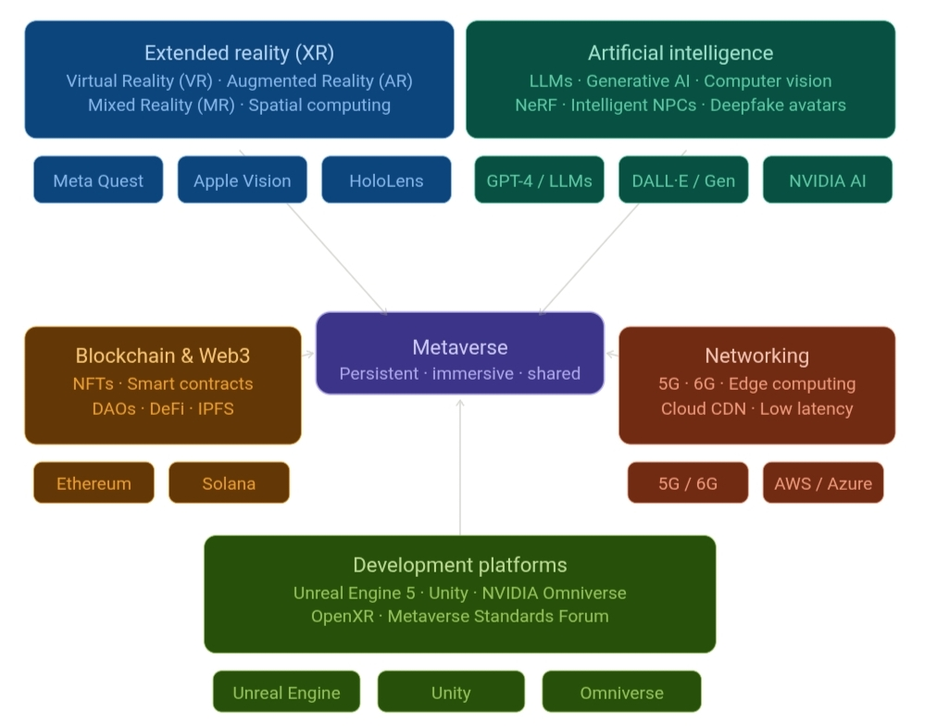
The Metaverse is being shaped by a constellation of technological advances occurring simultaneously across multiple domains. Understanding these developments is essential for appreciating both the current state of Metaverse implementation and the trajectory of future progress.
Figure 3.1: Metaverse Technology Stack Diagram
3.1.1 Extended Reality Hardware
The physical devices through which users enter immersive environments have improved substantially in recent years across every dimension that matters display resolution field of view positional tracking accuracy computational performance battery life and physical weight [16]. A new generation of spatial computing headsets released in the mid-2020s demonstrated the ability to composite virtual objects into the physical world with sufficient fidelity that the distinction between real and synthetic elements becomes genuinely difficult for the eye to detect. Standalone headsets — those that require no external computer have brought entry-level immersive experiences within the reach of a much broader consumer demographic than was accessible even five years earlier. Research continues form factors far smaller than current devices including contact-lens-scale displays and projection systems embedded in conventional eyeglasses frames.
3.1.2 Artificial Intelligence and Generative Systems
Recent advances in machine learning have had a more immediate impact on Metaverse development than perhaps any other single technology category [17]. Systems that generate photorealistic three-dimensional objects complete virtual environments and animated characters from text or image prompts compress what previously required months of specialist labour into hours of automated processing. Neural scene representation techniques enable the conversion of ordinary photographic collections into navigable three-dimensional spaces. Intelligent behavioural systems allow non-player characters to conduct open-ended conversations adapt to novel situations and exhibit personality traits that make them credibly lifelike companions or adversaries within a virtual world.
3.1.3 Distributed Ledger and Web3 Infrastructure
A significant development in the sustainability of blockchain-based Metaverse systems was the shift of the dominant smart contract platform from an energy-intensive consensus mechanism to one that uses a fraction of the computational work to validate transactions [18]. This transition resolved what had been one of the strongest objections to blockchain as environmental infrastructure and opened the door to broader institutional engagement. Additionally scaling architectures that handle transaction processing on secondary layers above the main blockchain have made it practical to support high-frequency microtransactions — tipping in-world purchases creator royalties — at costs low enough that economic interactions of very small monetary value become viable.

3.1.4 Telecommunications Infrastructure
The deployment of fifth-generation mobile networks in major urban areas has begun to close the gap between the network performance required for comfortable immersive experiences and what is practically available to mobile users [19]. The combination of high throughput and low response latency that characterises these networks makes it feasible to offload rendering computation from a user's headset to nearby edge servers enabling higher visual quality from lighter and less expensive hardware. Research programmes targeting the sixth generation of mobile networks are exploring frequency bands and antenna architectures that would reduce response times by a further order of magnitude potentially enabling entirely new application categories that require near-instantaneous network feedback.
3.1.5 Digital Twin Systems
The concept of maintaining an accurate continuously updated virtual replica of a physical asset has matured from an engineering curiosity into a mainstream industrial tool [20]. Major platform providers now offer cloud-based infrastructure specifically designed to host digital twins of manufacturing facilities transportation networks urban environments and individual machines with application programming interfaces that allow real-time sensor data to flow continuously into the virtual model. The natural convergence between digital twin systems and persistent virtual worlds is increasingly recognised as one of the more technically sound pathways to a Metaverse grounded in physical accuracy rather than pure fantasy.
3.2 Tools and Technologies
3.2.1 Development Engines and Authoring Platforms
The two dominant three-dimensional development engines — one produced by a games company that also operates a large digital distribution platform and one offered as a general-purpose tool with a particularly large community of independent developers — have both invested heavily in features targeting Metaverse use cases [21]. These include tools for creating photorealistic human characters global illumination systems that simulate complex light interactions in real time and cloud-based multiplayer infrastructure that can host large concurrent user populations. A third category of platforms oriented specifically toward industrial digital twin applications provides collaborative environments where distributed engineering teams can simultaneously work on the same large-scale simulation.
3.2.2 Blockchain and Token Standards
The technical standards governing how digital assets are represented on distributed ledgers have become an important part of the Metaverse infrastructure stack [22]. Two widely adopted token specifications handle the cases of unique non-interchangeable assets — such as a specific piece of virtual land or a particular digital artwork — and sets of interchangeable items respectively. A growing ecosystem of alternative blockchain networks offers different trade-offs between transaction speed cost and security allowing Metaverse developers to choose the foundation that best suits their application’s requirements.
Table 3.1: Comparison of Major Metaverse Platforms
Platform | Type | Blockchain | Key Feature
Meta Horizon Worlds | Centralized | None | Social VR Quest integration
Decentraland | Decentralized | Ethereum | User-owned land (MANA)
The Sandbox | Decentralized | Ethereum | UGC gaming (SAND token)
Roblox | Centralized | None | Largest user base UGC
Microsoft Mesh | Enterprise | None | Azure-powered collaboration
NVIDIA Omniverse | Enterprise/Dev | None | Digital twins simulation

3.2.4 Interoperability Standards
Recognising that a Metaverse in which users cannot move between platforms freely is fundamentally limited a cross-industry standards body whose membership spans the largest technology companies has been working to develop common specifications for avatar data formats asset packaging identity portability and inter-world communication protocols [23]. A separate hardware-focused standard already provides a unified programming interface that allows XR applications to run on different headset platforms without modification eliminating one significant fragmentation barrier. Progress on these standards is considered by many analysts to be the most important non-hardware factor in determining how quickly a genuinely open Metaverse can emerge.
Table 3.2: Summary of Key Tools and Technologies
Category | Tool / Technology | Purpose
3D Engine | Unreal Engine 5 | Real-time rendering world-building
3D Engine | Unity | Cross-platform XR development
Digital Twin | NVIDIA Omniverse | Collaborative simulation
Blockchain | Ethereum | NFTs smart contracts
Blockchain | Solana | High-throughput transactions
Networking | 5G / 6G | Low-latency connectivity
AI | LLMs / Diffusion Models | Content generation
Standard | OpenXR | Hardware interoperability

3.3 Sustainability and Societal Concern
3.3.1 Energy Consumption
The aggregate computational demand of a fully realised Metaverse — rendering photorealistic environments for billions of simultaneous users running the artificial intelligence systems that populate those environments maintaining distributed ledger records of all digital asset transactions and operating the data centres and network nodes that tie everything together — represents an energy consumption challenge of significant proportions [24]. Current data centre infrastructure already accounts for a meaningful share of global electricity consumption and extrapolating current growth trajectories suggests that unconstrained Metaverse scaling would substantially increase that share. Mitigating this will require a combination of hardware efficiency improvements algorithmic optimisation renewable energy procurement for data centre operations and the continued replacement of computationally wasteful consensus mechanisms with more efficient alternatives.
3.3.2 Digital Inclusion
The risk that Metaverse technologies primarily benefit those who already enjoy technological privilege is a recurring concern in literature and in policy discussions. High-fidelity immersive hardware carries a price point that excludes large portions of the global population; high-speed low-latency network connectivity — a prerequisite for comfortable shared immersive experiences — is unevenly distributed even within high-income countries and far more so globally. If Metaverse develops primarily as a premium experience for affluent users it risks deepening the social and economic divides it might otherwise help to bridge. Addressing this will require deliberate design choices — prioritising lightweight access modalities that work on modest hardware — alongside targeted public investment in connectivity infrastructure.
3.3.3 Privacy and Data Governance
The sensors embedded in immersive virtual reality hardware are categorically different in their intimacy from those in a conventional smartphone [25]. They capture not just location and behavioural data but the precise movements of the user's eyes the micro-expressions of their face the exact posture and gestures of their body and potentially physiological signals such as heart rate variability that carry information about emotional state. Aggregated and analysed at scale this data could enable a degree of psychological profiling and behavioural prediction far beyond what any existing digital platform can achieve. Building trustworthy Metaverse systems will require privacy protections to be designed in from the outset rather than bolted on after deployment along with regulatory frameworks that give users genuine meaningful control over their biometric data.
3.3.4 Mental Health and Psychological Wellbeing
The psychological dimensions of extended immersion in virtual environments are not yet well understood empirically but the theoretical grounds for concern are real. Immersive virtual worlds are specifically designed to be engaging and rewarding which creates conditions favourable to compulsive use patterns. The ability to inhabit a persona very different from one's physical self raises questions about identity formation and the maintenance of a coherent sense of self across virtual and physical domains. Social interactions conducted through avatars in virtual spaces may or may not develop the same qualities as their physical counterparts. Systematic longitudinal research is urgently needed alongside thoughtful platform design that incorporates usage guidance and clear boundaries between virtual and physical engagement.
3.3.5 Legal and Regulatory Landscape
Metaverse presents legal systems with questions they were not designed to answer. When a dispute arises between users from different countries interacting in a virtual world hosted by a company based in a third country and governed by smart contracts running on a blockchain with no defined jurisdiction which legal system applies and which court has authority? How should income earn through virtual economies be taxed? What intellectual property protections apply to virtual creations and how should infringement be detected and remedy in three-dimensional shared spaces? These questions remain substantially unresolved and the absence of clear answers creates both risks for users and uncertainty for developers and investors. International regulatory coordination will be essential to produce frameworks that are coherent across borders and keep pace with technological development.
3.4 Conclusion
The Metaverse stands as one of the more genuinely transformative technological prospects of the current era not because any single component of it is unprecedented — immersive displays distributed ledgers and intelligent software systems have all been topics of research and development for years — but because the simultaneous maturation of all these components is creating conditions in which their combination becomes practically achievable at scale for the first time.
What this seminar has attempted to demonstrate is that understanding the Metaverse requires holding multiple frames simultaneously. It is a technical architecture involving layers of infrastructure hardware software and standards. It is a set of application domains with demonstrated value across education healthcare entertainment commerce and collaboration. It is the subject of a growing and increasingly rigorous body of academic research. And it is a set of societal challenges involving energy equity privacy psychological health and governance that must be confronted honestly rather than deferred.
The literature review reveals broad scholarly agreement that Metaverse is a legitimate and significant area of inquiry while also identifying substantial open questions at both the technical and social levels. The interoperability challenge in particular stands out as the factor most likely to determine whether Metaverse evolves into an open user-empowering platform or a collection of competing proprietary environments that capture rather than liberate the people who use them.
The technical landscape is moving rapidly. Hardware is becoming lighter more capable and less expensive each year. Generative artificial intelligence is dramatically reducing the cost of creating rich virtual content. Network infrastructure is delivering the performance characteristics required for comfortable shared immersive experiences to an expanding share of the global population. These trends suggest that Metaverse will be an increasingly present feature of professional and personal life over the coming decade.
The decisions made now — about standards about privacy protections about energy sourcing about equitable access about safety — will shape the character of that presence. The purpose of technical education about the Metaverse is not merely to produce engineers who can build it but to develop informed professionals who can build it well.

